





  

Solution for Emission Inventories



SEVEN2ONE‘S FLEXIBLE SOLUTION FOR EMISSION INVENTORES ...

## ... enables you to compile data from various sources in a central database efficiently, where it is

stored in a structured manner that supports the TCCCA principles.

A solution for you

Seven2one’s solution for emission data management supports you as environmental agency throughout your entire workflow from the data input all the way through the report submission.

Our solution enables you to compile data from various sources in a central database, where it is stored in a structured manner that supports the TCCCA princip- les.

Increase the efficiency for your processes. The Seven2one solution helps you to optimise and automa- tise your data management and report submission tasks. By freeing up significant time, you will be able to focus on improving the quality of your emission inven- tory.

You can easily adjust the inventory to your country‘s requirements. Furthermore, our solution provides you the flexibility to adapt quickly to new or different data providers, new (calculation) methods and new or chan- ging reporting categories.

## The features at a glance

* Record activity data, emission factors and emissions for greenhouse gases and air pollutants as time series including projections
* Import data from different sources directly from Mi- crosoft Excel files in a central data base
* Increase transparency by adding documentation
* Perform database-wide calculations of time series in- cluding Monte Carlo simulation for uncertainties
* Use automatic quality checking procedures for data validation
* Create your submission reports with just a few clicks

**Our references**

**Several environmental agencies have been managing their emission inventories for over ten years with the Seven2one soluti- on, e.g. Swiss Federal Office for Environ- ment and Umweltbundesamt Germany.**

2

Seven2one Solution for Emission Inventory 3

## Input data in various ways



Input data from different sources with heterogeneous structures manually or automatically. All gathered va- lues are tagged automatically with the change date, user and source. Deleted or modified values display their historic meta data in the value history.

## Manage data

Customise your information for faster comprehension and access, using different views (CRF, NFR, SNAP) to manage and analyse your data. The solution can be easily adjusted to support new or modified formats. Emission inventory compilers can work securely and flexibly in a space where they can create, edit and de- lete their own views according to their respective ac- cess rights. Inventory data can be made available to other departments or external recipients as needed.

Customise your data for faster comprehension and access. Document data according to your needs.

## Perform calculations

Calculate emissions automatically. You can perform simple calculations, such as aggregations, or more elaborated ones using our special calculation tool. This tool provides mathematical and statistical standard functions and supports loops and conditions. Use our customised add-in for Tier 1 and 2 methods to calcu- late uncertainty distributions using the Monte Carlo simulation.

## Run validations

Validate your data using our integrated plausibility checks, value documentation standards and quality le- vels defined by you. Run checks for the entire database using various validation criteria. Ensure for example that aggregated bottom-up numbers are never larger than the corresponding energy balance.

## Create reports

Analyse data, create reports and update data for new submission periods with our Microsoft Excel-based re- port generator. Rely on valid and up-to-date reports that contain values directly linked to the database. You use these reports to generate UNECE reports, Key Ca- tegory Analysis or to create charts and tables for the National Inventory Report (NIR).

# YOUR WORKFLOW WITH SEVEN2ONE

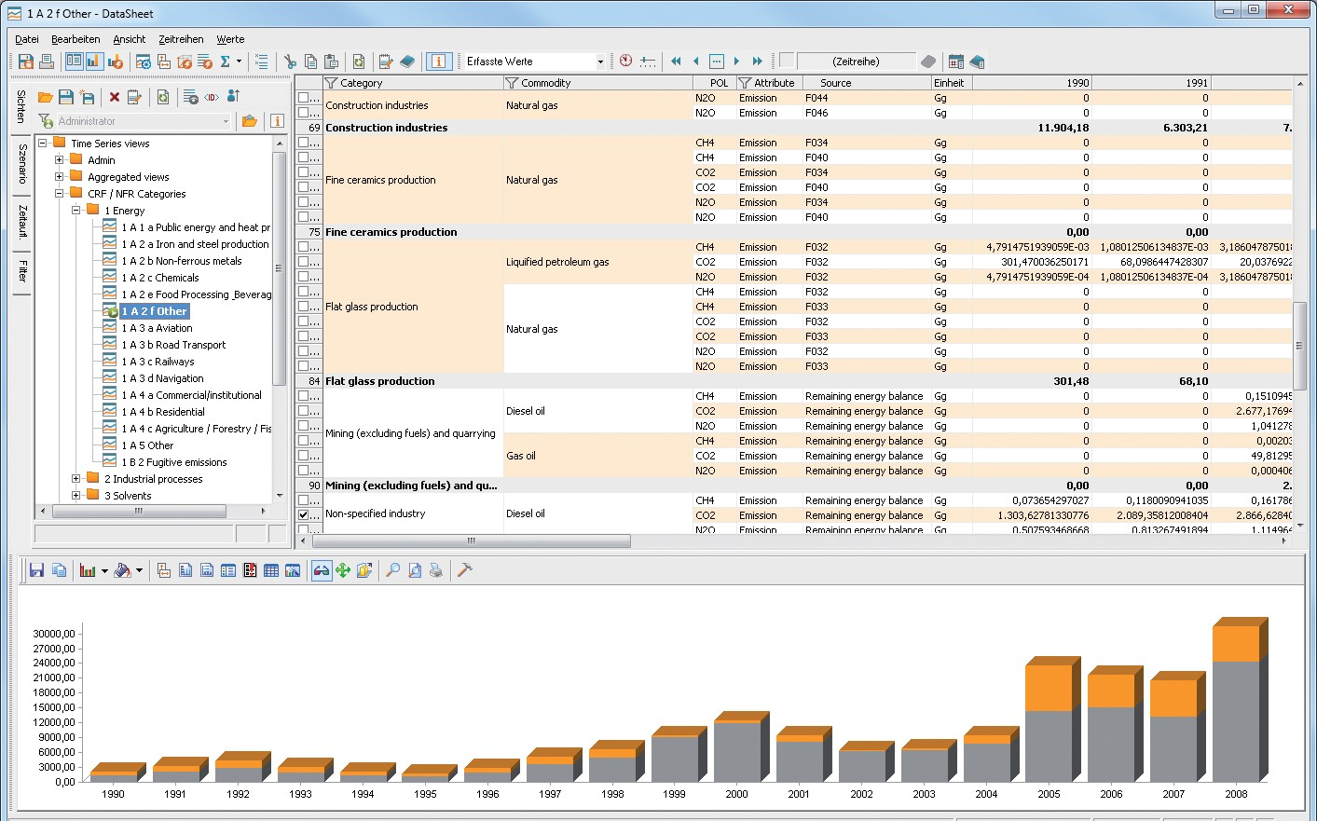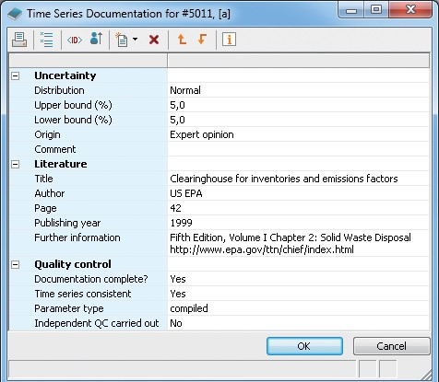

## Our solution captures and validates data from various sources and stores it in a central database. This data becomes the reliable basis for your reports and analy- ses that can be automatically generated, updated and distributed.

4 Seven2one Solution for Emission Inventory 5

# YOUR BENEFITS

## Transparency

Optimise and automatise your data management and report submission tasks with the Seven2one solution. By freeing up significant time, you will be able to focus on improving the quality of your emission inventory and to provide data that match the TCCCA principles.

Consistency

Comparability

Data can be stored on CRF and NFR aggregation levels, exported into CRF, XML and NFR spreadsheets. Simply reallocate sources into different CRF or NFR categories

## Completeness

The Seven2one solution gives you the flexibility to add new emission sources and emission factors quickly. Data gaps can be filled with easy-to-use interpolation and ex- trapolation methods.

Time [%]

100

Export to CRF and NFR Format

**-70%**

QA/ QC procedures

Calculations General handling

Data Input

80

60

40

20

Increase transparency levels by adding documentation and quality levels or create your own documentation

With the Seven2one solution you are able to define the granularity of activity data and emission factors

## Accuracy

0

Microsoft Excel

Seven2one Solution

structures including libraries and file attachments. You will work with values that are automatically document- ed with user name, date and source and keep historical values after recalculations.

freely – e.g. collect both energy balances and point source data. Ensure consistent data from individual or central emission factors that changes over time. You can also extrapolate data for projections.

For more accuracy you can add uncertainties for activity data, emission factors and direct emissions. Our software allows you to perform Tier 1 and Tier 2 analyses on differ- ent aggregation levels.

Manage your inventory in less time and submit your reports with just a few clicks.

 

6 Seven2one Solution for Emission Inventory 7



  

Seven2one Informationssysteme GmbH Waldstraße 41– 43



76133 Karlsruhe

T +49 721 62714-000

[info@seven2one.de](mailto:info@seven2one.de)

[www.seven2one.de](http://www.seven2one.de/)

© Seven2one, 2013



Description of Mesap

### Contents

|  |  |  |
| --- | --- | --- |
| 1. Approach of the proposed solution | | - 2 - |
| 1.1 Advantages of the proposed solution | | - 3 - |
| 2. Mesap as central data hub | | - 5 - |
| 3. Basic system landscape | | - 7 - |
| 4. Mesap modules | | - 8 - |
| 4.1 | Mesap Explorer | - 8 - |
| 4.2 | Time Series Component | - 9 - |
| 4.3 | Mesap DataSheet | - 10 - |
| 4.4 | Documentation | - 11 - |
| 4.5 | Importer | - 11 - |
| 4.6 | Automatic emission calculation | - 11 - |
| 4.7 | CalQlator | - 12 - |
| 4.8 | Analyst - Microsoft Excel based reporting | - 13 - |
| 4.9 | QA/QC | - 14 - |
| 4.10 | Uncertainty and Key Category Analysis | - 15 - |
| 4.11 | Konverter | - 17 - |
| 4.12 | CRF Exporter | - 17 - |

1 | 17



### Approach of the proposed solution

To establish and maintain a national emission inventory requires great efforts for data research (activities, emission factors, uncertainties) as well as suitable tools and knowledge to manage data efficiently in order to optimally support emission inventory compilers in their workflows. Seven2one is a specialist for building up emission inventory databases. With our solution Inven- tories that is based on the Mesap software, we provide a well-proven data model to keep inven- tory data consistent and tools to automate complex and/or time consuming tasks. In joint agree- ment we adopt our data model to the unique requirements of a country and enable inventory compilers to implement emission inventory extensions without external help. Our aim is to sup- port inventory compilers in such a way they can spend more time on improving their inventory instead of consuming too much time for standard processes or for searching errors. The environ- mental agencies in Germany, Switzerland and Luxemburg rely on the Seven2one solution.

The Mesap platform is a standard software designed to develop individual solutions for analysis, planning and reporting in the energy and environmental sector. This modular software platform offers a flexible, generic data structure and includes standardized configurable modules support- ing data collection, data quality evaluation, data visualization, data refinement and enrichment, technical analysis, data distribution, workflow automation & orchestration and platform admin- istration.

Mesap establishes a central data hub to collect and store information from various sources in one place, such as activity data, emission factors, fuel parameters and emissions. Data is orga- nized using a common classification scheme similar to data warehouses. The scheme will be es- tablished according to the CUSTOMER requirements. For the proposed Integrated Database Mesap will handle time series data and time series documentation. All objects are configurable. The common Mesap classification scheme enables to flexibly establish relations between these objects.

Mesap is a Windows based client/server database application. It supports the database platforms MS-SQL-Server and ORACLE. A web browser based intranet access is available (not subject to this offer). Mesap is multi user capable, multi lingual and highly scalable. Mesap is a standard software package. Additionally, most adjustments can be done by means of configuration and not by programming.

One of Mesaps main strengths is its integration of data and its configurability. The platform of- fers flexible search, query, and calculation, analysis and reporting tools. Once data objects, inter- faces, calculation procedures and reports are configured, workflows (such as collecting, clearing, storing, analyzing and reporting) can be automated. Changing requirements, such as new re- porting guidelines, can be easily adopted and implemented by the Mesap administrator.

2 | 17



The development of Mesap began in 1991, at the University of Stuttgart, Institute for Energy Economics. Since 2001 it is commercialized, developed and supported by Seven2one. Mesap has proven its efficiency, productivity and performance in more than 50 installations in Europe. Be- side emission inventory systems it is used to report to PRTR, to inventory large point sources and waste management facilities. In the energy sector Mesap is used (among others) as Market In- formation System for energy traders and reporting system for power plant and grid operators.

#### Advantages of the proposed solution

The proposed strategic solution for the Integrated Database is based upon the standard Mesap platform. This allows a fast and secure implementation and guarantees easy and cost-efficient adjustments to future requirements. The main advantages are:

Fast and secure implementation

Mesap, as a standard software platform, is ready to go. There is no additional programming re- quired; functionalities will be implemented by configuration. This advantage will allow to imme- diately start building up the emission inventory. The services delivered by Seven2one to set up the Integrated Database are focused on specification, configuration, installation, training and project management. This guarantees a fast and secure project implementation.

Flexible extension

The Integrated Database based on Mesap can grow with the CUSTOMER requirements, e.g. to store activity data on a finer resolution or to introduce new reporting categories, such as re- quired in the IPCC guidelines 2006. Since the database can be expanded to include new con- tents without programming, changes can be conducted directly by the CUSTOMER team. The functionality of Mesap is continuously expanded and adopted to technological change by Seven2one, thus creating a secure foundation for future extensions.

Attractive total cost of ownership

Mesap can be installed throughout your organization and beyond. The license model comprises one server and client licenses. The number of purchased client licenses is assigned to concurrent access of users. New extensions are available through a software update maintenance agree- ment at a fraction of the development cost.

3 | 17



Proven reliability in a wide range of projects

The modular design, the flexible configuration and the available interfaces make Mesap a proven and sustainable solution. Mesap is a mature software platform with high integration po- tential, deep functionality, strong industry-orientation and high quality standards. Flexibility and versatility are unique features that have been successfully used to implement a wide variety of individual and tailor-made systems solutions. Our references provide solid evidence of the wide- ranging projects and number of concepts developed by our company – besides the environmen- tal agencies of Germany, Switzerland and Luxemburg also RWE Power, European Energy Ex- change EEX, E-Control, EnBW Trading, E.ON Energy Trading, Syneco and Axpo

4 | 17

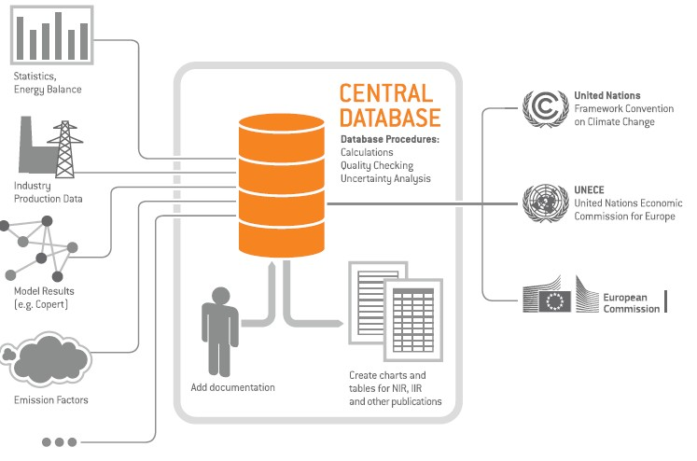

### Mesap as central data hub

The core of Mesap is a powerful database, in which all relevant information for storage, history and documentation of data are brought together in a central data pool. Mesap has a standard- ized data format and allows very flexible data handling. Similar to a data warehouse, Mesap stores time series data of any time resolution in a multidimensional structure. Activity data, emis- sion factors, parameters and emissions data from various external and internal sources can be administrated in a common context with reference to each other, thanks to the object-inde- pendent systematic approach of Mesap.

Time series are described by a set of customizable dimensions that contain a list of describing elements that are called descriptors. The combination of descriptors builds a unique descriptor key. This structure describes the data realm efficiently and avoids double counted time series. The user can create hierarchical trees, which help him navigate through data or allow aggrega- tion.

To each time series a documentation object can be linked. Furthermore, each times series value can be attached with documentation and a value history.

5 | 17

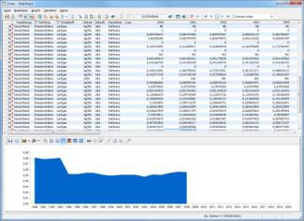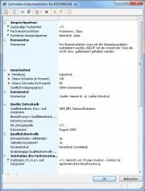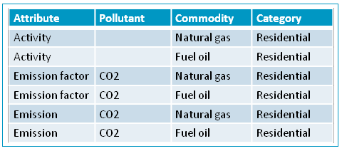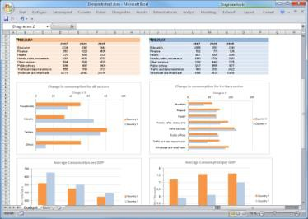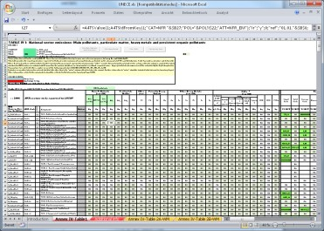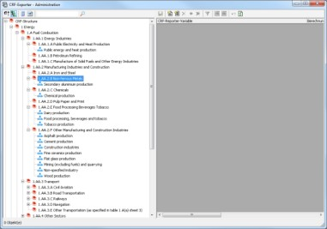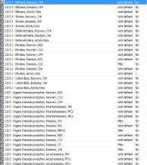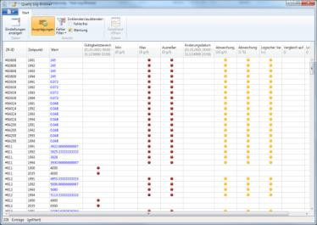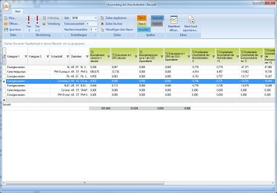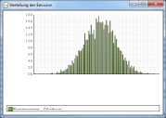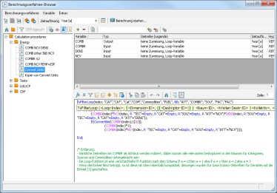

Data realm consisting of dimensions and descriptors

**Time series module Documentation**

The time series and documentation module are basic Mesap modules to view and enter data. Further modules serve for refining data, e.g. to create reports, execute quality checking or calcu- lation procedures. Some of the modules shown below have been exclusively developed for emis- sion inventory purposes.

**Report Generator**

**LRTAP Report**

**CRF-Export**

**Calculation module**

**Quality Check**

**Uncertainty analysis**

These Mesap modules operate with time series in an emission inventory system.

6 | 17

### Basic system landscape

Mesap is a distributed application. The components of the database server, application server, message server, can be distributed on to separate computers. They can however also all be in- stalled on a single computer.

The following figure shows the basic system landscape. The heart of this system is the Mesap Message Server, which is run on an Application Server at the CUSTOMER. The Mesap Message Server manages the communication and orchestration between all Mesap clients and services. The database can be run on a database server or on the same server with Mesap. The Mesap Message Server also communicates with the Mesap clients that are connected to the CUS- TOMER network. To these clients belong all computers that have installed the Mesap software. Clients outside the CUSTOMER network, such as external data providers, need to access a Ter- minal Server.

## CUSTOMER

External institute

Database Server

Application Server

…

Client PCs

External institute

Client PCs

Terminal Server

…

Client PCs



Mesap is a client/server application with triple layer architecture: data storage, application logic and user interface are separated into three levels. Oracle and Microsoft SQL Server can be used as database platforms, either separately or in a combined environment. An Oracle database server can also be run on UNIX.

7 | 17

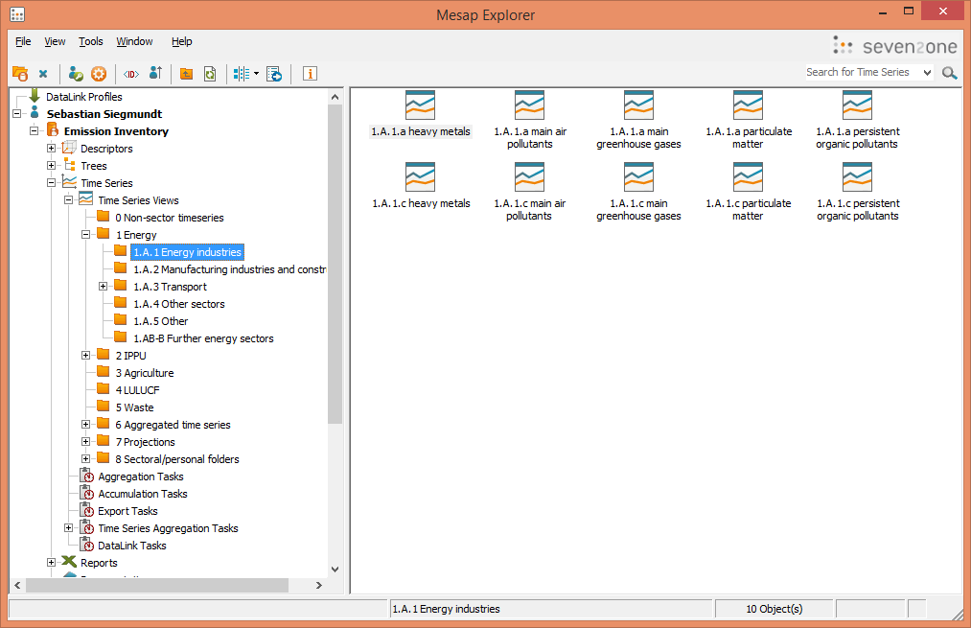

### Mesap modules

#### Mesap Explorer

Mesap Explorer provides central access to all the Mesap software functions. All the Mesap ob- jects are displayed in a hierarchical structure. To increase intuitive usability, presentation and functionality resembles the Windows-Explorer. The explorer enables users and administrators to log on and off.

Users can easily start all of their daily workflows from Mesap Explorer. Each user can adjust the explorer to suit individual needs. This applies to the language of the user interface as well as the appearance of the screen (minimizing of displayed objects for different needs, favorite tool bar for frequently used objects, Mesap objects displayed as symbols, lists or details). With the appro- priate access rights, Mesap objects can be viewed, processed and managed in the different modules.

Image 1: Mesap Explorer showing different customized time series views sorted into different folders

Mesap Explorer helps the database administrator to manage user access, user groups and con- figure all of the setup data in the database. This applies to specification of security updates,

8 | 17



quality definition as well as specification of standard values across the database. The system ad- ministrator uses the Mesap Explorer, too. It manages users present in the system, databases, ex- perience level and central system set up data including password guidelines, rules for account blocking and alias definition for frequently used networks.

#### Time Series Component

The Mesap Server time series Component stores selected time series data of any resolution in a standardized data model. The data is encrypted with identifiers from a catalogue. In this way a multidimensional structure like a data warehouse is produced.

Mesap offers many standard functions for the time series data:

* + - Administration and extension of any amount of time series of any resolution
    - Administration and extension of descriptors in any number of dimensions
    - Hierarchical structuring of the descriptors according to any desired category
    - Configurable documentation possibilities of the time series
    - Time series search using various search criteria
    - Administration of the time series in time series views, hierarchical structuring of the views
    - Integration of Times Series values from other Mesap databases and any number of exter- nal data sources via a standardised interface
    - Definition of virtual time series values, that can be calculated from other time series val- ues using the desired formulas
    - Use of various time zones in a data base
    - Online aggregation and disaggregation with different time resolutions
    - Data storage for any number of elements from the time series
    - User configurable documentation possibilities for the time series data
    - Interpolation rules to supplement gaps in the time series data
    - Extrapolation rules for extending time series data
    - Prioritization of hypotheses for supplementing gaps in the data
    - Configurable SI conversion (Système International)
    - Plausibility checks during data input
    - Change history (on/off switch-ability)
    - Individually definable characteristics for each time series (displayed unit, decimal places)
    - Task automation for time compression, accumulation, time series aggregation and ex- port

9 | 17

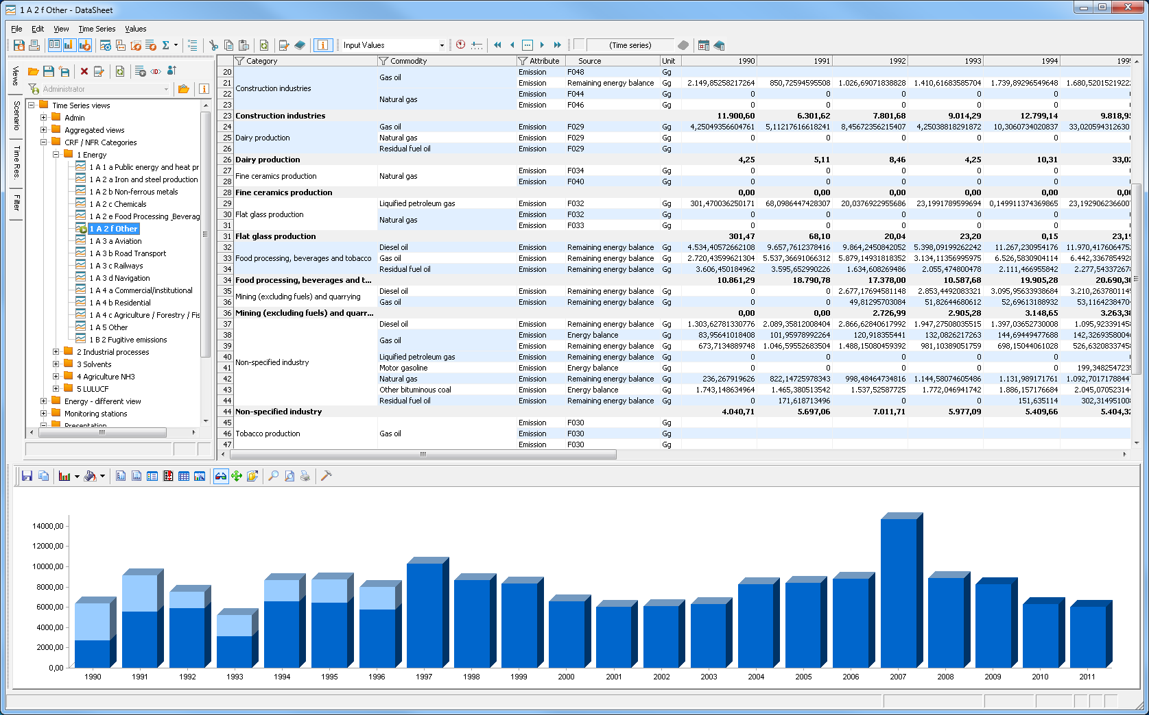

* + - Protection of time series values by assigning access rights to dedicated time series and their values for users and groups, definition of privacy levels, write protection flags and blocked time ranges

Further data analysis using external tools is enabled by the Mesap Export Routines or the Mesap API. The Mesap Export Routines produces extracts from the database (CSV, TXT, Access.mdb), which can then be read by the analysis tools.

#### Mesap DataSheet

The DataSheet allows to generate complex queries and to display the results as tables or graphs with only a few clicks. Users can also customize their tabular and graphic views and store them together with the filter parameters as a data view in specific folders. The DataSheet is also be used for data entry: plausibility checks like year-to year comparisons, superior and inferior limits can be configured for each time series and are executed during data entry.

Image 2: DataSheet View

10 | 17

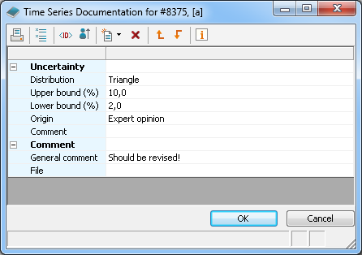

#### Documentation

Any time series, time series value, report or calculation procedure can be documented in a user- defined scheme consisting of different components and fields. Different field types are available,

e.g. free text, numbers, lists, file attachment and many more. Documentation can be used to at- tach uncertainties to time series and time series values. User defined citation libraries can be set up.

Image 3: Example of time series documentation

#### Importer

The Mesap Importer is a support program for importing time series data, master data, docu- ments and events. A standard format is used to describe the individual objects for import. Ob- jects that do not already exist in the database can be automatically created by the Importer after performing completeness and consistency checks.

There are two different formats available for importing time series data. This can be done either in a compact matrix to import all data points or in more detail with a row per value to allow thorough documentation of each value. The import format for master data also includes the possibility to import historical values.

#### Automatic emission calculation

The automatic emission calculation is a tool that has been specifically developed for emission in- ventory compilers. The tool searches for activity time series and finds the respective emission fac- tor. It calculates the emission, also taking notation keys into account. The automatic emission calculation is easier to use than the CalQlator, because only a time series filter and a time range

11 | 17

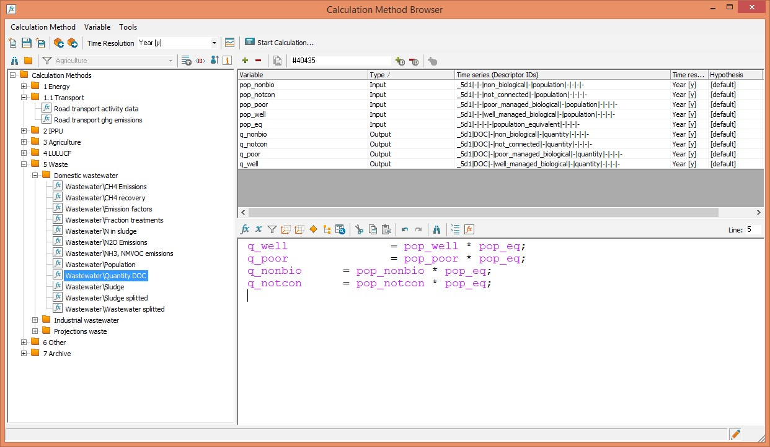

need to be defined. The tool also calculates the uncertainty for single emission time series using the Tier 1 method. The settings can be saved as task and executed by a single mouse click.

#### CalQlator

The CalQlator is a tool for performing calculations with time series and supports a wide range of operations – basic calculations, special mathematical functions, if-then-else interrogations and loops. Defining absolute or relative time indices enable calculations on different time levels. The obtained results can be stored in the database in form of time series for different hypotheses (scenarios) and time resolutions.

The CalQlator can also perform calculations for a set of time series by using time series filters and placeholders in a loop function. Users can preview the results using the Datasheet before the values are written into the database.

A possible use case is e.g. the conversion of different unit classes of fuels, e.g. mass and volume unites into energy units with regard to their net calorific value and their density (in case the fuel is a fluid).

Image 4: This screenshot shows a calculation procedure that determines quantities of DOC in waste waster

12 | 17



#### Analyst - Microsoft Excel based reporting

Data is no longer stored in Excel but within the flexible and powerful Mesap database. Thanks to the tight integration of MS Excel as a report generator, users are able to maintain their MS Excel logic. Mesap an Add-in for Excel, the Analyst report generator. The Analyst provides an online link to the Mesap database, which ensures that the Excel report always contains the up- to-date data from the database. All features of Excel are available to create tables, charts and reports or to calculate indicators, aggregations, statistical analysis and trends. With one mouse click standard reports can be adjusted to a shifted reporting period. Reports are automatically updated when adjusted to a new reporting period. There are several advantages of working with MS Excel Analyst as a report generator:

* + - Separation of Excel Worksheet calculations and data storage (Mesap database)
    - Always up-to-date data in Excel Reports
    - no more redundancies through central Mesap database
    - Easy migration of existing Excel tools into the new solution
    - Swift integration of the outputs with other MS Office tools
    - Reduction of learning periods

In the emission inventory, reporting air pollutant emissions to LRTAP and NEC is done by Analyst reports. Tables and charts for NIR and IIR reports are usually also generated by the Analyst.

13 | 17

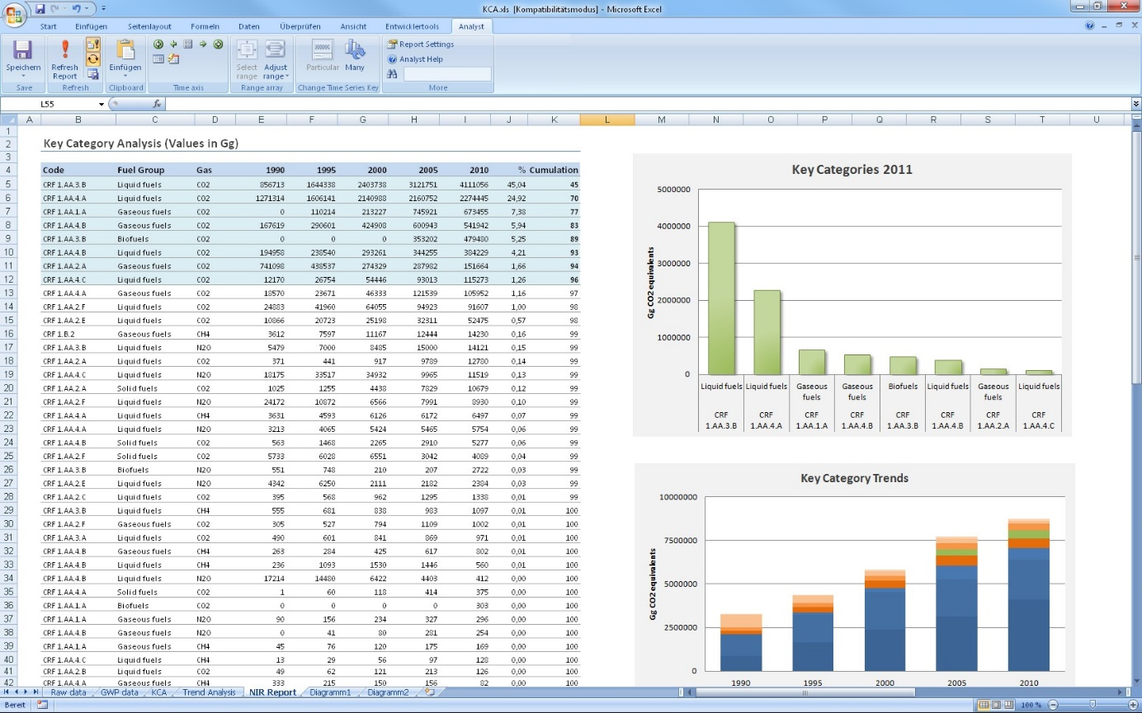

Image 5: Example of a Key Category Analysis made with the Analyst

#### QA/QC

The quality of the time series data can be checked with the Mesap Quality Check using various test methods. Numerous checking tasks can be prepared with the module, which can then be automated by the scheduler. First the time series to be checked are selected based on various selection criteria (time series code, time range, prediction, quality level of the data, etc.), and then the various checking methods can be applied.

The following checking methods are available:

* + - Definition of a validity range. With this method time series values are identified that lie outside of a defined validity range.
    - Expected or unexpected time values. Checking for expected values, a time point can be defined at which an error was reported where data is missing.
    - Checking for unexpected values, a time point is defined at which an error was reported and data is present.
    - Minimum and maximum values. Minimum and maximum values are defined. Should a value be below or above the expected, this will be reported as an error.
    - Find outliers: a threshold can be defined, which if exceeded is identified as an error.

14 | 17

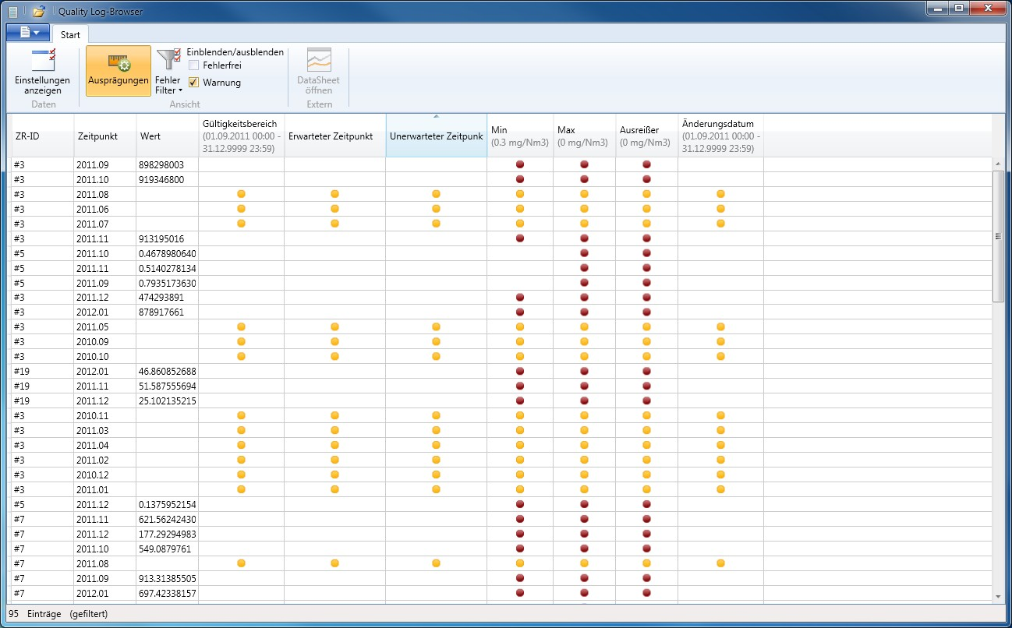

* + - Comparison check. This check compares values (absolute or percentage) according to predefined criteria. Time series can be compared with each other, with different hypoth- esis or with historic values. Time series can be checked for proportionality and deviation.

A Log file is compiled which is a detailed list all results of each completed test. In the Quality Log Browser, a specialized browser function supervises the validation results. Erroneous value correc- tion can follow. As a result of the test, the quality level for a value can be redefined. In this way checked values can easily be identified.

#### Uncertainty and Key Category Analysis

This tool calculates the uncertainty of user-defined categoriesaccording to 2006 IPCC Guide- lines. With Approach 1 method it aggregates the uncertainties of emission time series using a simple aggregation formula. With Approach 2 method it calculates the category uncertainty by performing a Monte-Carlo-Simulation that retrieves all respective activity and emission factor un- certainties. Depending on the uncertainty distribution of activity and emission factor data, the resulting category emission and its uncertainty can vary largely from Approach 1 results. Based on emission and uncertainty calculation Key Category Analysis may conducted and tables ac- cording to IPCC Guidelines are exported as csv files.

The user can define and save different analysis views and export the results into Excel.

15 | 17

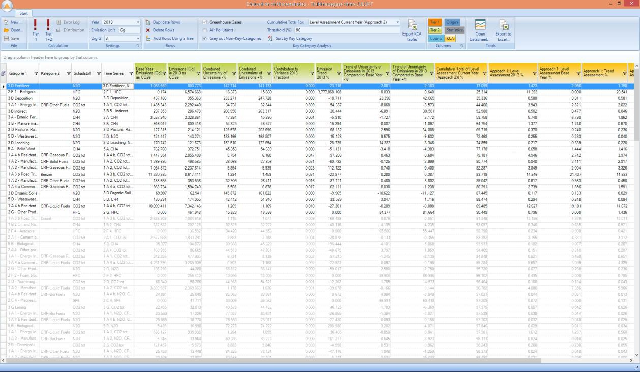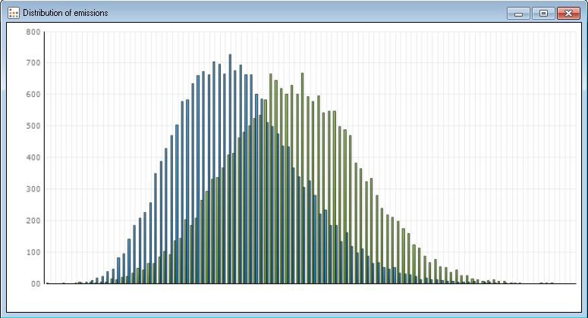

Image 6: Result view of uncertainty analysis

Requirements to conduct Approach-1 and Approach-2 uncertainty analysis:

* Uncertainties are stored as documentation to time series’ or time series values.
* Uncertainties need to be attached to each activity and emission factor time series OR time series value in order to calculate the uncertainty of the emission. If both time series and time series value provide documented uncertainties, priority is given to the uncer- tainty of the value.
* Only for direct emissions (or emissions not calculated in Mesap) the uncertainty has to be attached to the emission time series / time series value
* For uncertainty documentation component the user must provide a distribution (normal, lognormal, uniform, triangle) and the upper and lower bound of the 95% confidence level.
* The user defines uncertainty categories according to the IPCC guidelines or own catego- ries. The aggregated uncertainties of activity data, emission factors and emissions pro- vide only meaningful results, if uncertainties of all relating time series are complete.

16 | 17

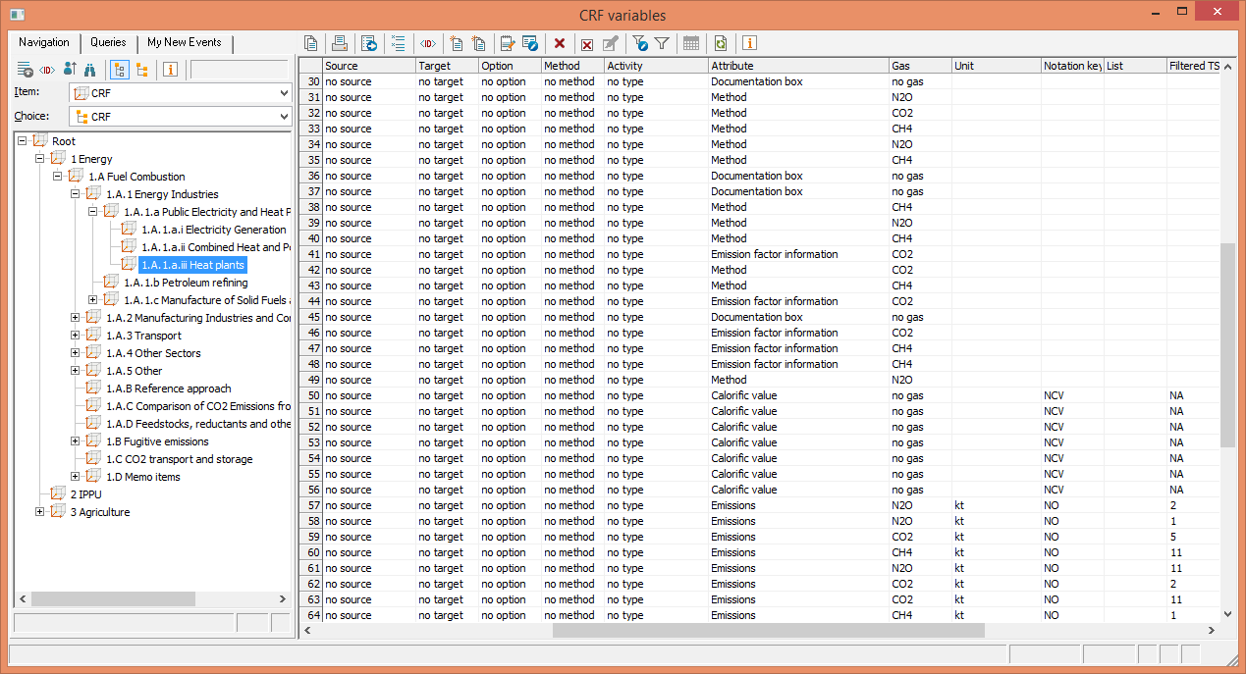

#### Konverter

With the Mesap Konverter, data available within an MS Excel file can be imported into the Mesap database. The file format is not fixed but can be defined by the user as a template. A conversion process can take place interactively or at a particular point in time. A template de- fines a particular import format and defines how the data can be transferred into the Mesap da- tabase logic. It contains information about the file format, guidelines for identification of the correct template, plausibility control rules as well as import rules for the data.

The Konverter is an Excel-based interface and that can be easily customized. Via the Konverter, users can easily and independently integrate new sources into the database and collect data with the required degrees of frequency and automation. The following data formats are sup- ported: .xls, .xlsx, .csv, txt, html plus other file formats that can be opened from Excel.

#### CRF Exporter

The CRF Exporter is a Mesap AddIn to aggregate time series and convert them into the CRF- XML-format. The created XML-file is then transferred to the UNFCCC CRF Reporter.

17 | 17